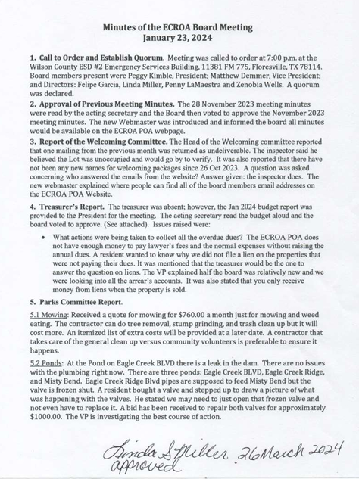
5.3 Parks: Discussed buying a special lock to control non-community members entering the park at night. The Lock has not been purchased yet. A key pad so only community members can enter the parks is also being considered. There is a resident that is locking the gates at night and opening them in the morning to keep non-residents out of the park at night. The VP did give him permission to do that.
6. ACC Report. The ACC Inspector, has had two people contact him about construction approval for new house plans and one resident wants a waiver for a metal roof. We have one residence that is not responding to letters about deed restriction violations. Consequently, the ACC will be bringing paperwork in for the next meeting so the Board can decide what the next step will be.
7. Old Business.
7.1 Meeting Schedule: A suggestion was made to change the meeting dates to every other month rather than 9-months out of the year. Discussion ensued on Texas Law versus POA laws. Discussion tabled until further research could be conducted.
7.2. Downed trees: Discussion about the downed trees on the intersection of Hunter’s Glen and FM775.
8. New Business:
8.1 Secretary resigned: After 7 years of dedicated service, Susan retired from the board. Consequently, a new Secretary must be elected. We will be advertising to fill the position.
8.2 Vandalism: A Mailbox at Misty Bend and Eagle Creek Dr. was ripped off its stand and stolen in December 2023. Also, vandalized was the stop sign at Wildflower & Palo Alto. No one indicated if the stop sign had been reported to the Sherriff or the county commissioner.
8.3 Street Lights: One of the street lights were out and a mailbox under the light was vandalized. The light was reported to FELPs and they repaired the light. The head of the Welcoming committee provided a list of all of our street lights with the associated FELPs Pole number and it was suggested we put it on the webpage so people can find their street light and report it by the FELPs number on the pole if it goes out.
8.4 Chickens/Fowl: There has been renewed interest from the community about raising chickens/fowls. This would need to come as a request letter from a registered member of the community to the POA asking that an amendment to the restriction be considered by the board, if feasible then a date would be set for it to be voted on by the membership at an annual or special meeting. Discussed what it will take to allow Chickens/Fowl and how many per acre would be allowed. Resident asked how many people have to approve the change – answer, 2/3s of membership have to vote for change. It was discussed whether we could change bylaws so that the voting block was made up of those that actually respond since so many residents don’t bother to respond to anything. Discussion ensued as to what fowl would be acceptable and how many per acre and what the chicken houses would look like.
8.5 Deed Restrictions: A resident asked where the deed restrictions were listed and another resident stated that the board needed to make sure all restrictions were treated equally. The board was not aware of any problems like that. An example of some residents already having chickens and nothing being done about it was provided. A discussion concerning 4H projects ensued. Another resident asked about the fines, if there was a list somewhere. The ACC mentioned during the Nov 2023 meeting they would see about compiling a list from the TX HOA page because they have a list of specific violations with a specific fine.
8.6 Web Issues: There is a missing form on the construction page of the website. The new webmaster is updating the webpage contents.
8.7 Speeding: Several residents are experience speeding down their road. The POA does not handle criminal activity; residents were directed to call the Sherriff’s Office.
8.8 Roberts Rules: A resident asked if we approved the minutes and the treasurer’s report through Robert’s Rules. The board apologized and immediately approved both through Robert’s Rules.
8.9 Dues Increase: Based on the discussion during the treasurer’s report, the process to raise the annual dues was discussed. This generated much discussion on raising the dues to pay for expenses. The board will research the process of raising the dues and provide response during the March meeting to residents who asked to have dues increased.
9. Adjourn. The meeting was adjourned at 8:00 p.m.

Attachment One – January 2024 Treasurer’s Report

